Task Description:

Launch an EC2 instance (Linux and Windows) along with a web server. Then, create an EBS volume of 5 GB, attach it to an EC2 machine (Linux and Windows), and take a snapshot. Finally, create an EBS volume using the taken snapshot.

Techstacks needs to be used :

- AWS EBS
- AWS EC2

OUTPUT
Linux OUTPUT
#!/bin/bash
sudo yum update -y
sudo yum install -y httpd
sudo systemctl start httpd
sudo systemctl enable httpd
echo "<h1>Welcome to Linux Web Server - Task 4</h1>" > /var/www/html/index.html

Create a file system on the volume:
sudo mkfs -t xfs /dev/xvdf

Verify it is successfully mounted:
df -h
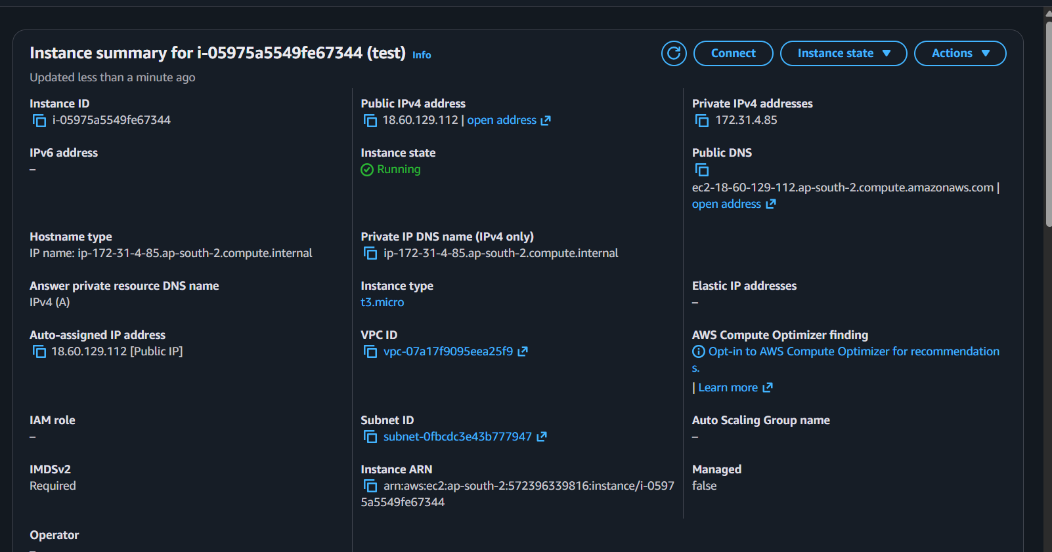
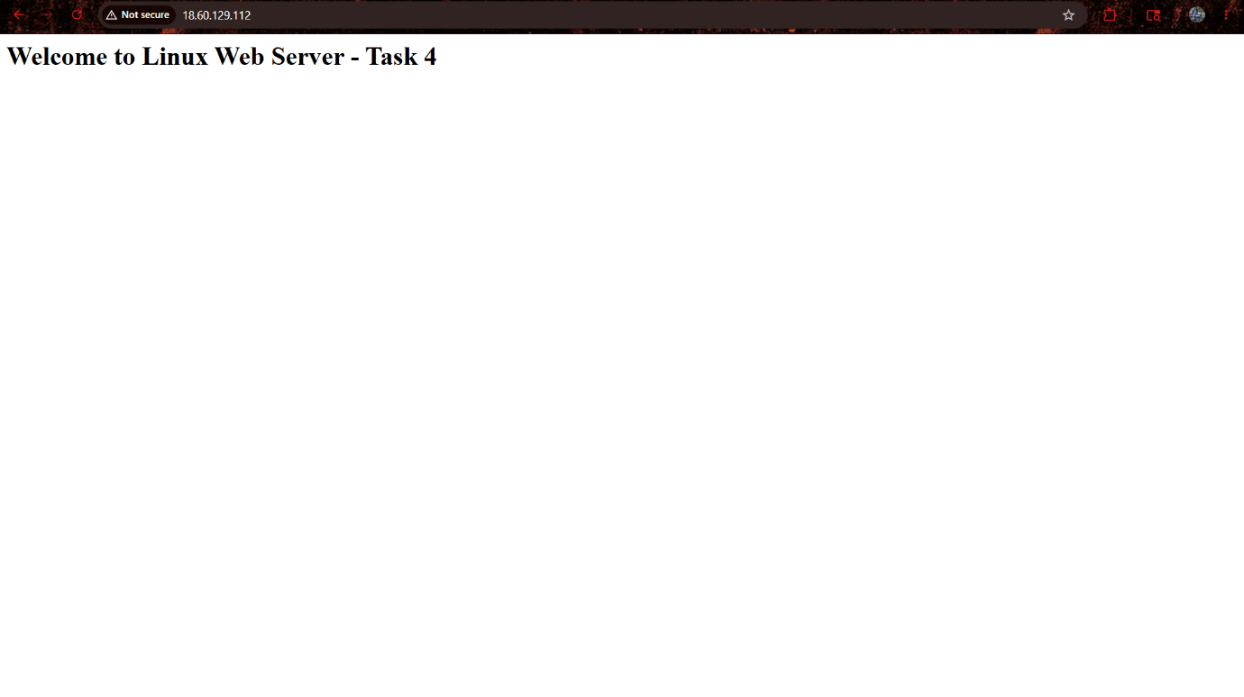

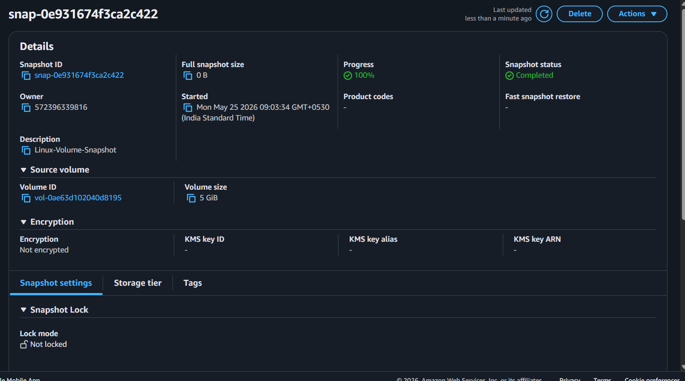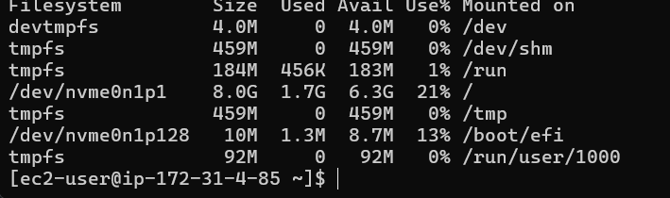

WINDOWS OUTPUT
